Deleting all the pre-existing tables, procedures, functions, sequences.

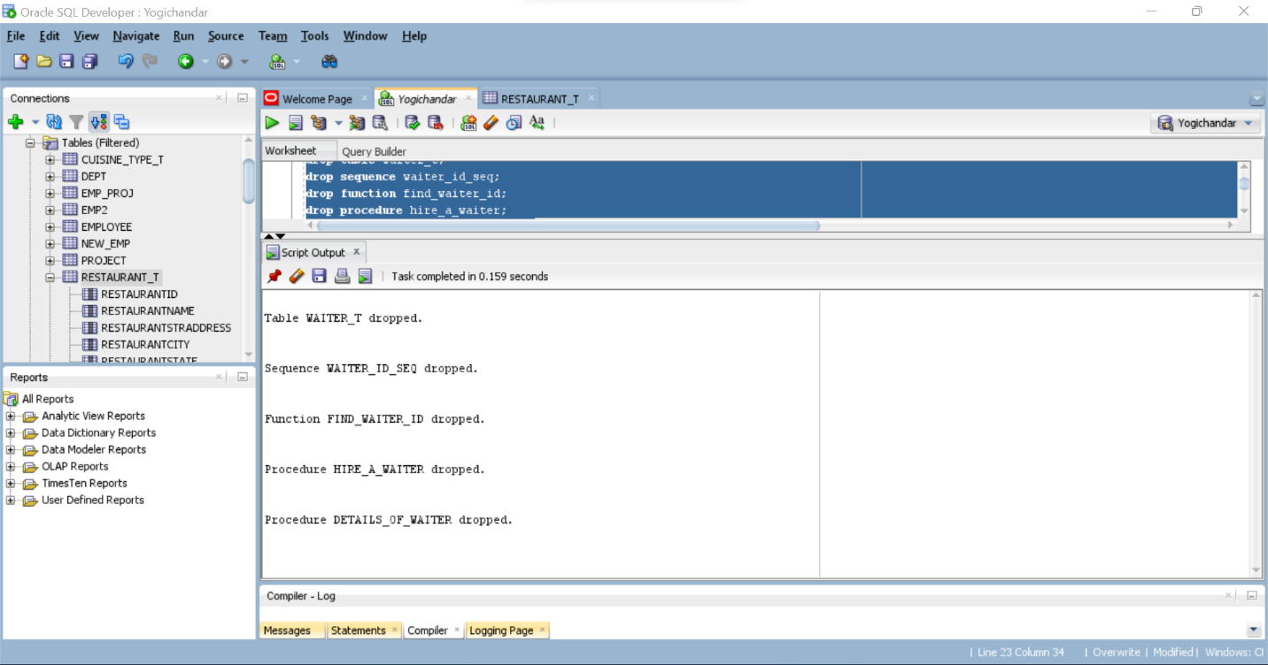

Creation of waiter table and deletion of existing data from the table:

Manual insertion of data into the waiter’s(waiter_t) table:

Data existing in the table after manual insertion:

Creation of hire_a_waiter and details_of_waiter procedure to insert/populate the data and show the waiters working in the restaurant.

For the hire_a_waiter waiter name(wname_insert) and restaurant name(rname_insert) are passed as parameters. These are passed using the ‘in’ mode.

The query output for insertion of data as per the scenario D2:

Output of workers working at bella italia restaurant:

Creation and compilation of find_waiter_id function:

The output of small code to test the function find_waiter_id:

The screen shots when the code is ran as a single script are enclosed below:

